Create – Advanced Search Technical Specification

Technical Specification

Version: 1.1
Date: 8/3/07
Submitted by: caAERS Project Team

Version History
Version | Date Modified | Author
1.0 | 7/16/2007 | Krikor Krumlian
1.1 | 8/3/2007 | Krikor Krumlian

Contacts and Support
KrikorKrumlian - kkrumlian@akazaresearch.com

LISTSERV Facilities Pertinent to software teams
LISTSERV | URL | Name
Caaersappdev-technical | caaersappdev-technical@gforge.nci.nih.gov. | caAERS technical forum
Table of Contents
1 Scope and Purpose 4
2 Overview 4
2.1 Features 4
2.2 Assumptions 4
3 Design Approach 4
3.1 Domain Objects 4
3.2 Persistence Layer 4
3.3 Service Layer 5
3.4 Controller Layer 5
3.5 View Layer 5
4 Implementation 5
4.1 Domain Model 5
4.2 Sequence Diagram 6
4.3 Activity Diagram 6
5 Testing 7
5.1 Domain Layer 7
5.2 Persistence Layer 7
5.3 Service Layer 7
5.4 Web Layer 7

List of Figures
Figure 1 6
Figure 2 7

Scope and Purpose
This document provides an overview of the proposed technical design of the Advanced Search features in caAERS. Where possible, accompanying UML models and documentation have been included as part of this document.

Overview

Features
This feature allows the caAERS user to do advanced searches to find appropriate Studies, Participants, Adverse Events, Expedited Reports and Routine Reports.
A new tab was added to the user interface to accommodate this feature. Inside this tab you will have the ability to choose to perform one of the five search tasks listed above.

Assumptions
Need to have data in the system to return the appropriate result sets.

Design Approach

Domain Objects
caAERS has a domain driven design with analysis starting from a BRIDG (Biomedical Research Integrated Domain Group) Harmonized model. A set of domain objects will be created in gov.nih.nci.cabig.caaers.domain. Once the domain model is finalized, an implementation, which identifies the Java classes, associations, is put in place. The domain objects are persisted using Hibernate and Hibernate 3. Hibernate annotations will be used for mapping to database elements instead of separate hbm files. These annotations can in turn be configured via Spring’s bean configuration files.

Persistence Layer
New Functionality was added to the DAO implementations already in place to support the Advanced Search Features. The Advanced Search Feature will only access the database via a DAO interface object.

Service Layer
The service layer will expose a set of interfaces for the client to call in (currently the interface decided is a Web Interface). The Controller classes typically delegate the functionality to Service classes. Spring adds the dependency injection for the implemented classes as Controller need not be coupled with the SAM.

Controller Layer
Spring’s MVC is being used as the MVC architecture for caAERS. All the Controller classes for the respective use case will be located in the package gov.nih.nci.cabig.caaers.web

View Layer
The view technology incorporated in caAERS consists of JSP pages, css, AJAX and tag libraries included from Spring.

Implementation

Domain Model

No domain model changes have been done for this feature.
https://gforge.nci.nih.gov/plugins/scmsvn/viewcvs.php/docs/models/caAERS.EAP?root=caaersappdev&view=log

Sequence Diagram
Core controller of the Advanced Search Tasks is based on Spring’s SimpleFormController. This controller will load the initial page where a set of search criteria exist. The user inputs the criteria he wants to search on and executes the search.

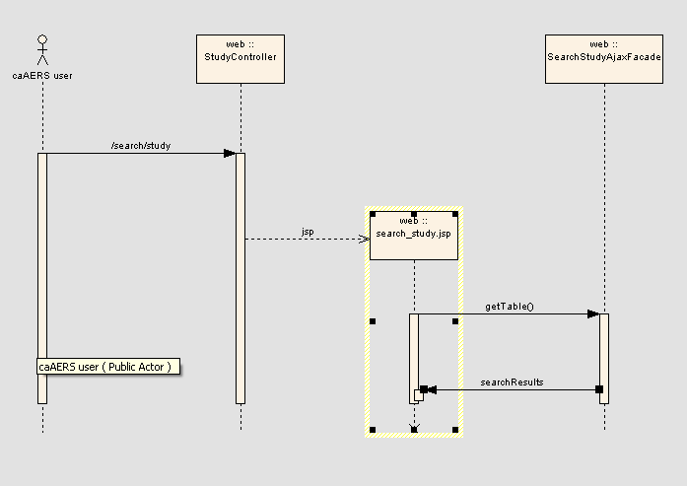

Activity Diagram

The Study Search Page

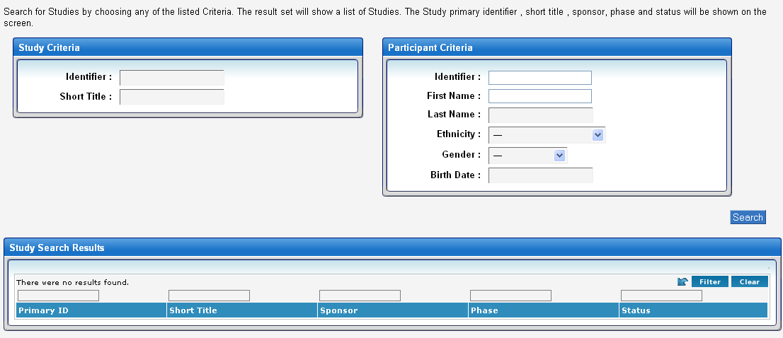

The Search Criteria
- Study Identifier: the study’s identifier value
- Short Title: the study’s short title
- Participant Identifier: the participant’s identifier value
- Participant First Name: the participant’s first name
- Participant Last Name: the participant’s last name
- Participant Ethnicity: the participant’s ethnicity
- Participant Gender: the participant’s gender
- Participant Birth Date: the participant’s date of birth

The Study Search Results
- Primary Id: the primary identifier of the study.
- Short Title: the short title of the study.
- Sponsor: the Sponsor of the study.
- Phase: the study phase.
- Status: the study status.

The Participant Search Page

The Search Criteria
- Study Identifier: the study’s identifier value
- Short Title: the study’s short Title
- Participant Identifier: the participant’s identifier value
- Participant First Name: the participant’s first name
- Participant Last Name: the participant’s last name
- Participant Ethnicity: the participant’s ethnicity
- Participant Gender: the participant’s gender
- Participant Birth Date: the participant’s date of birth

The Participant Search Results
- Primary ID: the primary identifier of the participant.
- First Name: the first name of the participant
- Last Name: the last name of the participant
- Gender: the participant’s gender.
- Ethnicity: the participant’s ethnicity.
- Associated Study ID(s): the Primary ID(s) of the studies associated with the current participant

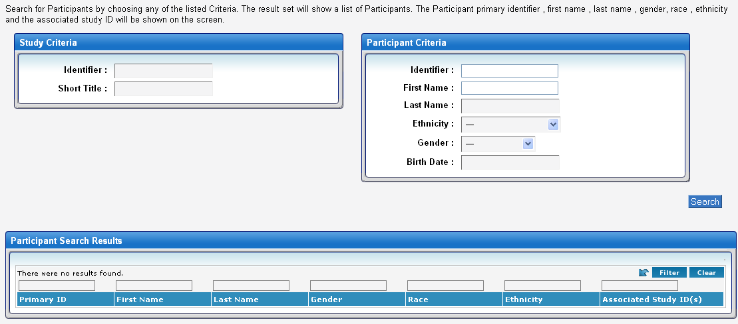

The Adverse Event Search Page ( Returns Routine and Expedited Adverse Events)

The Search Criteria
- CTC Category: the CTC Category of the adverse event
- CTC Term: the CTC term of the adverse event
- MedDRA Code: the MedDRA code of the adverse event ( mapped to the
CTC Term)
- Grade: the grade of the adverse event
- Identifier: the study’s identifier
- Short Title: the study’s short title
- Participant Identifier: the participant’s identifier value
- Participant First Name: the participant’s first name
- Participant Last Name: the participant’s last name
- Participant Ethnicity: the participant’s ethnicity
- Participant Gender: the participant’s gender
- Participant Birth Date: the participant’s date of birth

The Adverse Event Search Results
- Study ID: the primary identifier of the study associated to this AE
- Sponsor: the sponsor of this study
- AE type: the type of the AE that occurred
- CTC Category: the CTC category associated with the AE
- CTC Term: the CTC term associated with the AE
- Grade: the grade associated with the AE
- MedDRA Code: the MedDRA code associated with the AE
- Detection Date: the date this AE was identified

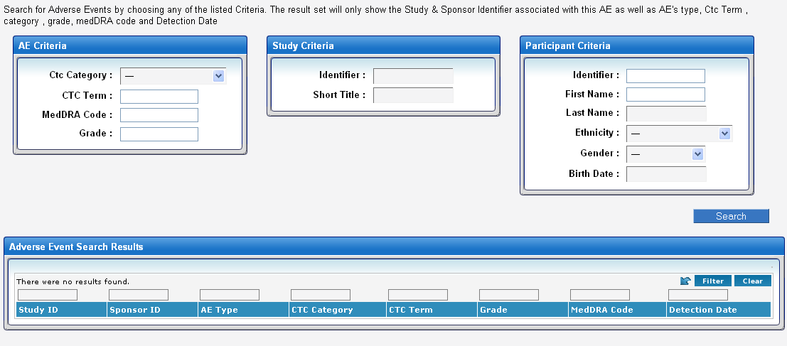

The Expedited Adverse Event Report Search Page

The Search Criteria

- Detection Date: the detection date associated with this report
- CTC Category: the CTC Category of the adverse event
- CTC Term: the CTC term of the adverse event
- MedDRA Code: the MedDRA code of the adverse Event (mapped to the CTC Term)
- Identifier: the study’s identifier
- Short Title: the study’s short title
- Participant Identifier: the participant’s identifier value
- Participant First Name: the participant’s first name
- Participant Last Name: the participant’s last name
- Participant Ethnicity: the participant’s ethnicity
- Participant Gender: the participant’s gender
- Participant Birth Date: the participant’s date of birth

The Adverse Event Search Results
- Primary CTC Term: The CTC term associated with the primary AE of this report
- Attribution: The attribution of the primary AE associated with this report
- Detection Date: The detection date of this report
- Study ID: The primary identifier of the study associated to this report.
- Participant ID: The primary identifier of the participant associated to this report.

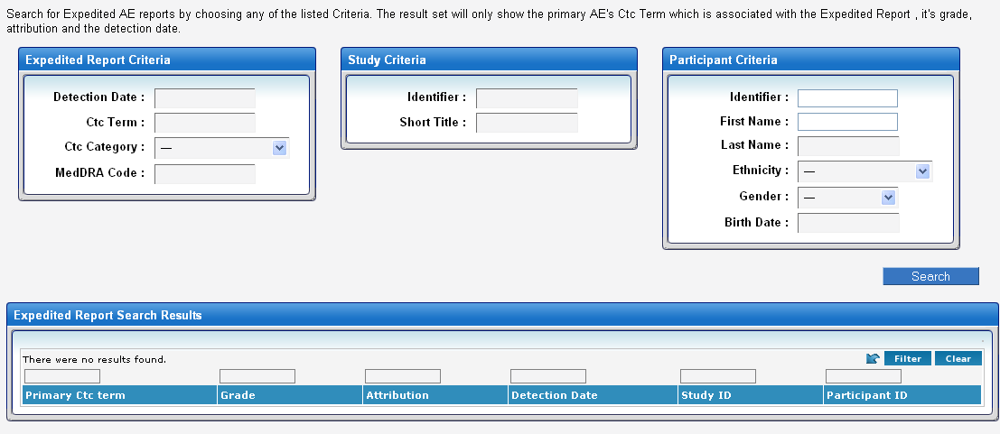

The Routine Adverse Event Report Search Page

The Search Criteria

- Observation Date : The start/end date associated with this report
- CTC Category: the CTC Category of the adverse event
- CTC Term: The CTC term of the adverse event
- MedDRA Code: The MedDRA code of the adverse Event ( mapped to the CTC Term)
- Identifier : The study’s identifier
- Short title : The study’s short title
- Participant Identifier : The participant’s identifier value
- Participant First Name : The participant’s first name
- Participant Last Name : The participant’s last name
- Participant Ethnicity : The participant’s ethnicity
- Participant Gender : The participant’s gender
- Participant Birth Date : The participant’s date of birth

The Adverse Event Search Results
- CTC Category: the CTC category associated with the AE
- Primary CTC Term: the CTC term associated with the primary AE of this report
- Attribution: the attribution of the primary AE associated with this report
- Observation Date: the start/end date of this report
- Study ID: the primary identifier of the study associated to this report.
- Participant ID: the primary identifier of the participant associated to this report.

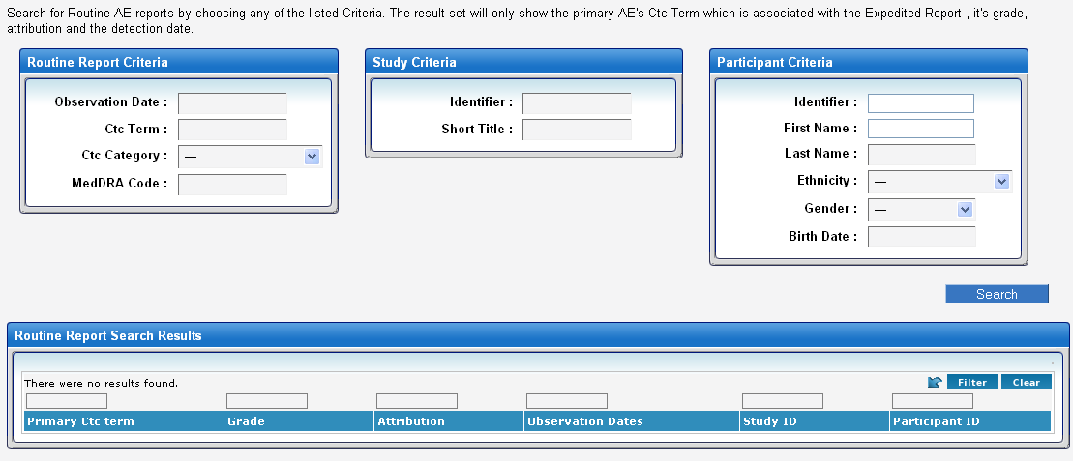

Testing

Domain Layer
No tests available for the domain layer.

Persistence Layer

Test Class Name | Target
gov.nih.nci.cabig.caaers.dao.StudyDaoTest.java | Tests added in the StudyDaoTest to test the queries associated with searching for study(ies).
gov.nih.nci.cabig.caaers.dao.ParticipantDoaTest.java | Tests added in the ParticipantDaoTest to test the queries associated with searching for participant(s).
gov.nih.nci.cabig.caaers.dao.AdverseEventTest.java | Tests added in the AdverseEventTest to test the queries associated with searching for adverse events.
gov.nih.nci.cabig.caaers.dao.ExpeditedAdverseEventReportTest.java | Tests added in the ExpeditedAdverseEventReportTest to test the queries associated with searching for expedite adverse events.
gov.nih.nci.cabig.caaers.dao.RoutineAdverseEventReportTest.java | Tests added in the RoutineAdverseEventReportTest.java to test the queries associated with searching for routine adverse events.

Service Layer

No Service layer code present for this feature

Web Layer

Test Class Name | Target
gov.nih.nci.cabig.caaers.web.StudyControllerTest.java | Tests the controller
gov.nih.nci.cabig.caaers.web.ParticipantControllerTest.java | Tests the controller
gov.nih.nci.cabig.caaers.web.AdverseEventControllerTest.java | Tests the controller
gov.nih.nci.cabig.caaers.web.ReportControllerTest.java | Tests the controller
gov.nih.nci.cabig.caaers.web.RoutineReportControllerTest.java | Tests the controller

